School of Accountancy Faculty Meeting Minutes
November 27, 2017
1:30 p.m. to 3:00 p.m.

Attendees: Shirley Daniel, Liming Guan, Boochun Jung, Manu Ka’iama, Thomas Pearson, Mohsen Sharifi, Jenny Teruya, Mary Woollen, Tu Xu, David Yang, Jian Zhou, and Hamid Pourjalali
Excused Absence: Roger Debreceny (away for the semester)
The two agenda items were as follows:
Advisory Board issues and Director's Circle: To become a Director’s Circle, a donation of $500 minimum will be required. Fujii, Nishikawa, Pourjalali, Daniel, and Teruya had already made their donations. The subject will be discussed in the Advisory Board meeting and the membership will be asked for yearly donations.

The Recruiting Committee reported on the application pool. Jung will attend Rookie Camp in Miami to interview PhD applicants. Pourjalali reported that the Dean had allowed recruitment for two positions. As a result, the Committee will be recruiting for two positions.

The meeting adjourned at 2:30 p.m.

Minutes for SOA faculty meeting held on Oct. 30, 2017
from 1:30 pm – 3:00 pm in A-301 (PWC Seminar room)

Attendees: Shirley Daniel, Liming Guan, Boochun Jung, Manu Ka’iama, Tom Pearson,
Mohsen Sharifi, Jenny Teruya, Mary Woollen, Tu Xu, David Yang, and Jian Zhou.
Excused Absences: Roger Debreceny (away for the semester) and Hamid Pourjalali
Visitors: Qi-Mei Chen (Asso. Dean) and Steve Mar (lecturer next spring)

- Associate Dean Qi-Mei Chen came and discussed SOA recruiting.
- Minutes of Sept. 11th (were approved after replacing “a motion” with discussion on
Acc 705 changes). The revised minutes are attached.
- A motion was unanimously passed to adopt the Acc 705 changes.

- Steve Mar was introduced. He will teach Acc 619 in the spring. He retired last year from
internal audit work at Nordstroms. He has taught part-time at Seattle University.
Mar briefly describe his course plans with student projects at UH and
involvement of the professional community in Hawaii.
- A motion was unanimously passed that “Students should take the 3-2 program or the MAcc
as the most efficient way to pass the CPA exam.”

- A motion was unanimously passed that “SOA will work with college to request the financial aid greater support for students pursuing the 3-2 and MAcc degrees, particularly allocating accounting industry scholarships and allocating a fair portion of college funds to provide financial support for Macc and 3-2 program students.”

- CPA Exam course mapping was discussed. A motion was unanimously passed to replace the current CPA exam sheet recommended coursework provided to students by OSAS
with a simplified course mapping sheet for each section of the CPA exam (see attached).

8. Course catalog topics were discussed. A motion was unanimously passed
to add faculty expertise in the catalog. Faculty were given two days to review it.

9. A motion was unanimously passed to eliminate two 500 level classes (584 and 585). It was noted that FEI wants to use a 500-level accounting class in their proposed Master of Finance.
A vision for retaining some of the 500 level courses was discussed; it was noted that 400 level classes exist in tax and audit. The motion modified the name of the 500 level “cost accounting” course to “managerial accounting.”
10. A motion was unanimously passed to revise the MAcc description (to clarify that concentrations are optional, the existence and names of the three concentrations (taxation, financial reporting and assurance, and data analytics).

- A few curriculum concerns were introduced (such as technology). Discussion was postponed for the next SOA meeting.
12. Discussed whether to add a fifth objective to the MAcc. Because the proposed objective relating to CPA exam preparation did not blend in with the conceptual topics in the current objectives,
no motion was raised to add a fifth objective.
13. It was raised that the next SOA Advisory Board meeting is December 4th.
14. Guan reported that he would work with Pourjalali and Pearson on the Assessment Report
for UH-Manoa, due by mid-November.
15. The proposed emeritus policy unanimously passed, see attached.

16. Other agenda items were postponed to the November 2017 meeting.
The meeting adjourned at 3:03 p.m.

School of Accountancy Faculty Meeting Minutes - September 11, 2017

Attendees: Shirley Daniel, Liming Guan, Boochun Jung, Manu Ka’iama, Thomas Pearson, Mohsen Sharifi, Jenny Teruya, Mary Woollen, Tu Xu, David Yang, Jian Zhou, and Hamid Pourjalali
Excused Absence: Roger Debreceny (away for the semester)

The meeting commenced at 1:35 p.m.
Minutes of April 24, 2017 meeting were approved.
Pourjalali welcomed Tu as SOA’s new faculty, Moshen as our visiting faculty, Shirley as returning from leading a UH study abroad program in Italy, and David back from sabbatical.

Pourjalai mentioned the Dean is aware of SOA’s financial needs and fundraising opportunities for naming the School.

SOA Recruitment issues were discussed. Four applicants were identified by the recruitment committee for a skype interview.

The New UH/UHPA (2017-2021) contract might require that the SOA review some of its policies, make necessary adjustments, and approve them within 6 months of the contract agreement. This item was postponed for a future SOA faculty meeting [UPDATE - Bev. Cleaver said as long as ours clearly follow the union contract, it’s ok

Pourjalali reported that the College CPC was considering the equivalency of UH West Oahu business core courses. Courses in the majors were not considered. The subject will go to Shidler faculty Senate for vote after the CPC makes its recommendation about core business courses.
Curriculum Changes:
1) Recall that last spring SOA voted to reduce the number of credit hours from 3 to 2 for Acc 407 (taxation of business entities) and Acc 660 (the capstone course). The faculty also voted to create two one credit courses. For administrative ease in staffing and offering 3 credit hours to students per night, the faculty voted unanimously to offer “Acc 660 (2 credit) and Financial Statement Analysis (1 credit)” together (co­requisites). Similarly, “Acc 407 (2 credit) will get offered with Forensic Accounting (1 credit)” (co­requisites). The course numbering of the new courses would maintain a similar 400 and 600 level designation [425 – forensic accounting and 648 – financial statement analysis].
2) The faculty discussed modifying one word in the title of a Ph.D. seminar: ACC 705. The revised title is “Research in Auditing.” The modified course “Provides an overview of accounting research in auditing and international accounting topics. Specific research studies are examined as to their theoretical basis, design, implications, methodology, relevance, etc. A­F only. Pre: PhD student status in business or consent.”
3) SOA’s PhD committee will review in the future whether the PhD courses should more clearly signal the research methodologies taught (empirical, archival, behavioral), rather than an emphasis on an accounting sub-discipline – financial, audit, systems …).
4) The faculty supported a prerequisite change for Acc 631 (Tax of Partners/Partnerships) from Acc 407 to Acc 401. This change will enable more students to take this important tax course.
5) A question was raised to assess if non­tax MAcc courses need revision or reduction in credit hours to enable MAcc students to get exposed to more topics and better prepared for strong CPA exam results. The subject was postponed to a future SOA meeting.
Reports:
6) Teruya and Ka’iama provided reports on BAP and Accounting Club activities. The UH Accounting Club was 1 of 12 student chapters to receive an award from the IMA. BAP got recognized once again by national as a superior chapter.
7) Jung provided the names of the Shidler speakers for 2017­2018. The speakers are Michael Drake, BYU (November 3rd), Jee­Hae Lim, Waterloo [in Canada] (Jan. 22nd), Gwen Yu, Toronto (March 2nd), and David Wood, BYU (April 6th).
8) Zhou provided a brief report on the Audit Educators’ Bootcamp in Chicago. Teaching auditing through cases was emphasized; Zhou indicated that he already started to use more cases in his teaching.
9) Woollen provided a report on her summer meetings on brain science as it relates to learning and retaining information. She indicated that she was using new methods in her classes to help students retain the topics that they learn. Woollen agreed to present more information at a future UH system Accounting faculty meeting.
10) Guan serves on the College Assessment Committee. He indicated that he would be compiling a multi-year assessment report for the MAcc and would contact faculty for help.
The meeting adjourned at 2:40 p.m.

Recommended Coursework for CPA Exam Sections
UH-Manoa Accounting Curriculum Mapped to CPA Exam Sections
CPA EXAM  SECTIONS | Accounting  Major Courses | MAcc Courses with  Significant CPA Content
Regulation  (REG) | 401 Federal Individual  Income Taxation -37%-47%  460e Capstone - Tax and Ethics -5% | 407 Taxation of Business Entities -28%-38%  413 Law for the Accountant -10%-20%  605 CPA Review – Regulation -all
Audit and  Attestation  (AUD) | 418 Auditing –50%  460d Capstone – Auditing  and Acc’g Information Systems -5% | 602 CPA Review –Audit and  Attestation –all  619 Information Assurance and Analytics  -5-10%
Fin’l Acc. & Reporting (FAR) | Introductory accounting courses  321 Intermediate Financial Accounting I –25%  323 Intermediate Financial Accounting II –25%  460c Capstone – Financial -5% | 415 Advanced Financial Accounting  -10%-25%  616 Accounting Theory and Development  -20%-30%  604 CPA Review – Financial Accounting  and Reporting -all
Business Environment Concepts (BEC) | 409 Accounting Information Systems  -15%-25%  460b Capstone - Managerial –5%  Business core courses | 610 International Corporate Governance  -10%-25%  603 CPA Review – Business  Environment and Concepts -all
(Rough percentages show the estimated topical coverage of relevant exam section,
based on 2017 blueprints for the CPA exam and 5% for capstone classes,
reflecting the nature of the exam is now 50% simulations in most sections)

184 Shidler College of Business 2018-2019

MBA Admission Requirements
…
Admission requirements for the Master of Accounting pro- grams are found in the “Accounting” section within the Shidler College of Business. Admission requirements for the PhD program in Business Administration are found in the “PhD in Business Administration” section of this Catalog.
…

Master of Accounting
The Master of Accounting (MAcc) degree provides an advanced education in accounting in taxation, financial reporting and assurance, accounting, audit- ing and data analytics necessary for students to pursue leading positions in public practice, business, government, and related fields..
The program offers students the opportunity to adequately prepare for today’s multifaceted accounting practice by strengthening their understanding of the body of accounting knowledge, as well as preparing them for the complexities and new technology facing the accounting profession.
The objectives of the program include: a) providing the educational opportunity necessary for students to become qualified professional accountants for leading positions in public practice, business, not-for-profit organizations, government, and related fields; b) enhancing students’ intellectual and analytical skills with research skills necessary to further educate themselves after graduation, including exposure to leading high technology; and
c) enhancing students’ professional communication skills necessary for success in a contemporary accounting environment.
Completion of this program will fulfill the State of Hawai‘i’s 150 credit hour requirement for Certified Public Accountant Licensure. In addition, there are opportunities available to study abroad (Asian Field Study), as well as internships (up to 3 graduate level credits), and career development services to further enrich and support your undergraduate and graduate accounting studies. CPA Review preparation, internship, career development services, and other opportunities further enrich and support your graduate accounting studies.
MAcc students may choose one of three suggested concentrations: financial reporting, data analytics, or tax.
Admissions Guidelines
- GPA 3.0
- GMAT taken within the last 5 years and a score of at least 500
- International Students: TOEFL 600 or IELTS 7.0 scores*
- No work experience is required
*Applicants who do not meet these requirements may still be granted admission but may be required to take a placement exam at the time of matriculation and/or to take English lan- guage classes in addition to their MAcc course work.

3/2 Master of Accounting
The 3/2 Master of Accounting (MAcc) program is an inte- grated, five-year 150-credit hour program designed for students at the Shidler College of Business who want to earn both undergraduate and graduate degrees in accounting. Students in this program gain the skills necessary to build a successful career in the multifaceted, dynamic practice of accounting. Current undergraduate students may apply to the program during their junior year. This program is for stu- dents who wish to enter professional careers in public practice, business, non-profit organizations, and government sectors.
Completion of this program will fulfill the State of Hawai‘i’s 150 credit hour requirement for Certified Public Accountant

2018-2019 Shidler College of Business 185
Licensure. In addition, there are opportunities available to study abroad (Asian Field Study), as well as internships (up to 3 graduate level credits), and career development services to further enrich and support your undergraduate and graduate accounting studies. CPA Review preparation, internship, career development services, and other opportunities further enrich and support your graduate accounting studies.
MAcc students may choose pursue one or more of the three concentrations: taxation, financial reporting and assurance, or data analytics.
Email: macc@hawaii.edu

Master of Human Resource Management
…
188 Shidler College of Business 2018-2019

.
Accounting
School of Accountancy BusAd C-306 2404 Maile Way Honolulu, HI 96822 Tel: (808) 956-7332 Fax: (808) 956-9888
Web: shidler.hawaii.edu/soa

Faculty
*H. Pourjalali, PhD (Director)—managerial accounting, financial accounting, international accounting
*S. Daniel, PhD— auditing, managerial accounting
*R. Debreceny, PhD— auditing, financial accounting, accounting information systems
*L. Guan, PhD—accounting information systems, financial accounting
*B. Jung, PhD—financial accounting
M. Kaiama, MAcc, MA Hwst —financial accounting, auditing, ethics, not-for-profit accounting
*T. Pearson, LLM/JD— tax accounting, ethics
*J. N. Teruya, PhD— financial accounting, managerial accounting, international accounting
*J. Wendell, PhD—accounting
M. Woollen, MAcc— financial accounting, managerial accounting, tax accounting
*D. C. Yang, PhD— financial accounting, international accounting, sustainability accounting
*J. Zhou, PhD— Auditing, Financial accounting, International accounting, Managerial Accounting
Degrees Offered: BBA in accounting, MAcc, PhD in business administration International (accounting concentration)

Tu Xu - Auditing, financial accounting, accounting information systems
Degrees Offered: BBA in accounting, MAcc, PhD in business administration International (accounting concentration)

The Academic Program
The School of Accountancy within the Shidler College of Business offers the Bachelor of Business Administration (BBA) with a major in accounting (ACC) and the Master of Account- ing (MAcc) degrees. The undergraduate accounting program provides students with the knowledge and skills forming an educational foundation for entry into a wide range of accounting-related careers and enables students to
pursue graduate or advanced professional education. The MAcc program provides advancedaccounting education in taxation, financial ac- counting, and auditing reporting and assurance, and data analytics necessary for students to pursue leading positions in public practice, business, not-for-profit organiza- tions, government, and related fields.
An accounting background will provide a competitive edge for those aspiring to become chief financial or chief executive officers. Students often study accounting even though their major interests may be in other areas of business. This enables these students to have a salable skills for easy entry into a business firm. Some students study accounting even if their primary interest resides in another business area because an accounting education enables them to have a valuable knowledge and skills for easy entry into a wide variety of businesses.

Mission
We are an academic community with the Shidler College of Business, whose mission is:
To provide students with an accounting education relevant to a technologically advanced global economy; to advance ac- counting knowledge through research; and to instill students with a sense of moral, ethical, and professional obligation to society.

Accounting Careers
The accounting profession may be divided into the following two major segments.
Public Accounting
Specialties in this area include auditing, tax, and manage- ment advisory services. Some of the larger firms have reorga- nized these activities along industry lines. Students entering public accounting should prepare to become a Certified Public Accountant (CPA). Many students who graduate with an ac- counting degree are employed by national or international CPA firms, or by local CPA accounting firms. Some open their own independent practices after they become certified.
Other Accounting Jobs
Accounting positions in industry are available in firms engaged in manufacturing, wholesaling, retailing, banking, transportation, insurance, and real estate, as well as in hotels, entertainment enterprises, and restaurants. Positions in these organizations can be found in the areas of financial accounting, managerial accounting, internal auditing, tax accounting, and accounting information systems. Graduates also find employ- ment as accountants in various branches of federal, state, or local governments or in not-for-profit organizations. Accounting positions in private industry, not-for-profit organizations, and government. Private industry jobs may involve all or part of the various areas of accounting, financial, managerial, accounting information systems, taxes, but emphasis differs depending on the type of job such as a comptroller, chief financial officer, internal auditor, forensic investigator, or credit analyst. In government accounting graduates work in all the branches of federal, state, or local governments.

Undergraduate Study

BBA in Accounting
Major Requirements (19 hours)
■ ACC 321, 323, 401, 409, 418, and 460B, C, D, E
For information on a Bachelor Degree Program Sheet, go to www.manoa.hawaii.edu/ovcaa/programsheets/.

Graduate Study

MAcc Degree
Admission Requirements
In addition to the Shidler College of Business graduate admission requirements, students without an undergraduate degree in accounting are required to complete the following undergraduate deficiencies in accounting: ACC 201 and 202 prior to admission to the MAcc program, and ACC 321, 323, 401, 409, and 418 prior to graduation.
Admission to the MAcc program is competitive. The School of Accountancy seeks individuals who have the potential for outstanding achievement in accounting, auditing, analytics, or taxation. The admis- sions committee primarily considers the candidate’s academic record and GMAT score and places emphasis on strong com- munication skills.
Degree Requirements
The MAcc degree requires 30 credits.
Required Accounting Courses (15 credits)
- ACC 407 Taxation of Business Entities (2)
- ACC 415 Advanced Financial Accounting(3)
- ACC 425 Forensic Accounting (1)
- ACC 616 Accounting Theory and Development (3)
- ACC 625 Accounting and Tax Research (3)
- ACC 648 Financial Statement Analysis (1)
- ACC 660 Analysis and Decision-making (2)

Complete 15 credit hours of electives, at least 9 hours of which are in accounting
Students may take any two of the following:
Courses from the Tax or Financial Reporting tracks provided that they are not fulfilling ACC Elective requirements Need 9
.
- Students can take any 400-600 level accounting course, those from an accounting concentration are encouraged
  - But Not courses used
to fulfill deficiency or core requirements.
  - Not ACC 460.
  - Maximum 6 hours from the 400-level.
- ACC 602 (AUD), 603 (BEC), 604 (FAR), 605 (REG) - CPA Review (4)
- ACC 695 Accounting Internship (up to three credit hours of an internship course can be taken for credit)
- Other accounting courses may include:
  - ACC 413 Law for the Accountant (3)
  - ACC 690 Current Topics in Accounting (3)
  - 400- to 600-level courses from the Shidler College of Business (BLAW, FIN, HRM, ITM, MGT, MKT, RE), the Field Study in Asia (BUS 677), or selected courses in PACE, LAW, COM, or COMG (business courses may not include MBA core classes BUS 621-632, BUS 696)
  - Students may petition other relevant graduate courses.
  - Maximum 6 hours outside of accounting
Students must complete a minimum of 30 credits to earn the Master of Accounting degree. If a course is waived, another course in the same area of study and of the same or higher level must be substituted.
Students have the option to pursue any concentration (taxation, financial reporting and assurance, or data analyticsElective Accounting Courses, three of from the following (9 credits)
Students can take any 400-600 level accounting course except ACC 460 and those courses used to fulfill deficiency or core requirements. No more than two elective courses may be from the 400-level. The following tracks are recommended:
Taxation concentration (any 6 credits, must be one of from the following)
- ACC 407 Taxation of Business Entities (2)
- ACC 631 Tax of Partners/Partnership (2)
- ACC 638 Estate and Gift Taxation and Planning (2)
- ACC 639 Multijurisdictional Taxation (2)
- ACC 695 Internship (in tax) (1-3)
- LAW school also offer tax courses
Financial Reporting and Assurance concentration (any 6 credits, must be one of from the following)
- ACC 610 International Corporate Governance (3)
- ACC 619 Advanced Auditing Information Assurance and Analytics (3)
- ACC 620 Global Accounting (3)
- ACC 635 Advanced Public Sector Accounting (3)
- ACC 695 Internship (in accounting or audit) (1-3)
- ACC 690 Current Topics in Accounting
Data Analytics concentration (any 6 credits from the following)
- ACC 619 Advanced Auditing Information Assurance and Analytics (3)
- Acc 649 Data Analytics for Accountants (1)
- ITM 683 Business Analytics and Business Intelligence (3)
- ACC 695 Internship (in data analytics) (1-3)
Thesis Option
In consultation with their advisor, a student may opt to do a research thesis in place of ACC 660 and three elective credits. Thesis students enroll in ACC 700 Thesis Research.

Accounting (ACC)
Shidler College of Business
ACC 500 Master’s Plan B/C Studies (1) Enroll- ment for degree completion. Repeatable unlimited times. Pre: master’s Plan B or C candidate and consent.
ACC 581 Financial Accounting I (5) Account- ing process and the application of GAAP to the recognition and measurement of cash, receivables,
inventories, property plant and equipment, deprecia- tion and depletion, intangibles, current liabilities, and long-term liabilities. A-F only.
ACC 582 Financial Accounting II (5) Applica- tion of GAAP in recognition and measurement of investments, pensions, retained earnings, and other topics related to financial statements. Other topics include consolidation and mergers and acquisitions. A-F only. Pre: 581.
ACC 583 Cost Managerial Accounting (5) Information for managerial decision-making, planning and control, job order and process costing, direct and absorption costing, standard and normal cost systems. Will also cover Government and Not-for-profit topics. A-F only.
ACC 584 Regulation and Accounting (5) Will cover tax accounting topics for individuals, estates, and business entities. Also will cover business law and professional responsibility topics important for the professional accountant. A-F only. Pre: 581.
ACC 585 Auditing and Attestation (4) Concepts include standards, objectives, and ethics for external auditors. Emphasizes reporting standards, internal control, statistical sampling, EDP audits, and assur- ance. Also covers information systems and relevant measurement topics. A-F only. Pre: 581.
ACC 602 CPA Review – Audit and Attestation (1) The Auditing and Attestation (AUD) section covers the entire auditing process, including auditing procedures, generally accepted auditing standards, standards related to attest engagements and the AICPA Code of Professional Conduct. Pre: 418 with C- or better.
ACC 603 CPA Review – Business Environment and Concepts (1) The Business Environment and Concepts (BEC) section focuses on business concepts and the significance of a CPA's professional duties and responsibilities within the larger context of the business environment.
ACC 604 CPA Review – Financial Accounting and Reporting (1) The FAR section focuses on U.S. GAAP, including concepts and standards for financial statements, typical items in financial statements, specific types of transactions and events, accounting and reporting for governmental entities, nongovernmental, and not-for-profit organizations. Pre: 323 with C- or better.

ACC 605 CPA Review – Regulation (1)
The Regulation (REG) section focuses more than 60%on federal taxation, especially taxation of business entities, individuals, and property taxation, but also tests knowledge on business law, business ethics, and professional and legal responsibilities. Pre: 401 with C- or better.
…
ACC 705 Research in AuditingTaxation (3) Provides an overview of accounting research in taxation auditing topics. Specific research studies are examined as to their theoretical basis, design, implications, methodology, relevance, etc. A-F only. Pre: PhD student status in international management business administration or consent.

School of Accountancy Procedure for Making a Recommendation
for the Award of Emeritus Status.

Background.
Board of Regents Executive Policy E9.209 (September 1990) provides for the awarding of emeritus status for retired faculty. The guidelines provide in part that:

III A.1 Persons retired from the University with the rank of full professor or its equivalent at a baccalaureate campus, or instructor V rank at the community colleges, and who have five or more years of service at that rank are eligible for emeritus status.

III B Since it [emeritus status] is an honor bestowed, not applied for, no documentation is expected or required.

The UH Manoa Guidelines for Requests to Award Emeritus Title provide in part that:

The request for emeritus title should be made after the retirement date and include the recommendation of the nominee's department and the Dean/Director.

In the context of these guidelines as they apply to the SOA “department” refers to the School of Accountancy and “Dean/Director” refers to the Dean of the Shidler College. The Manoa guidelines provide no guidance on how the department will make its recommendation. That being the case, the SOA adopts the following procedure.

Procedure

A SOA faculty member retiring with five or more years of full time service at rank 5 will automatically receive the recommendation of the SOA for emeritus status if they meet one or more of the following:
1. Received a University of Hawaii or Shidler College research or teaching award.
2. Held an endowed chair.
3. Served on one or more Ph.D. committees within five years of retirement.

Exceptions. On an exception basis, Deans and Directors may propose emeritus status for retired faculty who do not hold rank 5 status or lack the required 5 years. This request should be accompanied by the recommendations of the department and Dean, and a curriculum vitae if appropriate. Each case will be considered separately on its merits, and if Chancellor concurs, will be transmitted to the Board of Regents as an exception to BOR policy.

For SOA faculty not meeting the automatic criteria above, the SOA faculty will vote by secret ballot on whether or not to recommend the award of emeritus status. If the majority of the faculty voting recommend emeritus status be awarded, the SOA Director will notify the Dean that the SOA faculty recommends emeritus status be awarded. If the majority of the faculty voting recommend emeritus status not be awarded, the SOA Director will notify the Dean that the SOA faculty recommends emeritus status not be awarded. If there is an equal number of faculty recommending for and against awarding emeritus status, the SOA Director will notify the Dean that the SOA faculty declines to make a recommendation. The voting will be conducted in such a way that all faculty have an opportunity to vote including those traveling as well as those on sabbatical leave. The vote should be conducted during the on-duty period.

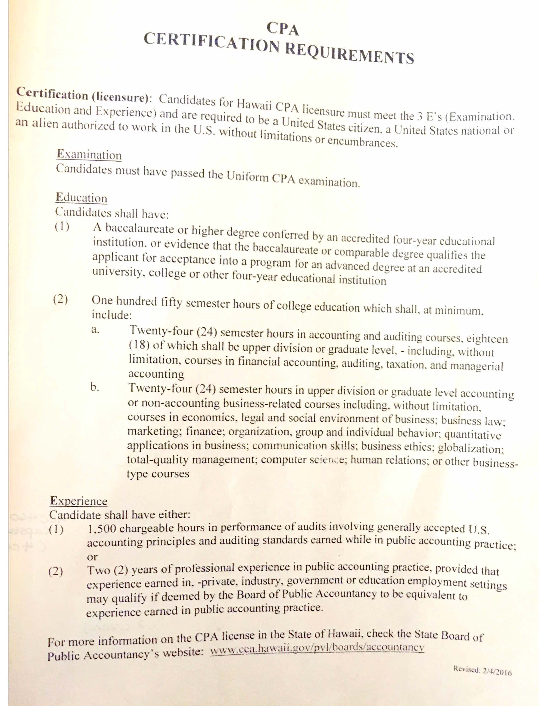
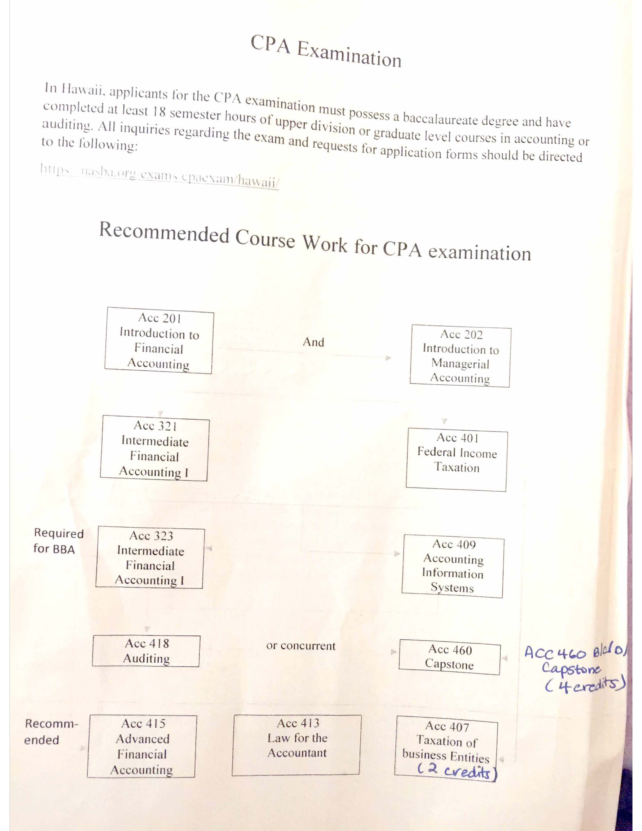

School of Accountancy Faculty Meeting Minutes
September 11, 2017
1:30 p.m. to 3:00 p.m.

Attendees: Shirley Daniel, Liming Guan, Boochun Jung, Manu Ka’iama, Thomas Pearson, Mohsen Sharifi, Jenny Teruya, Mary Woollen, Tu Xu, David Yang, Jian Zhou, and Hamid Pourjalali
Excused Absence: Roger Debreceny (away for the semester)
The meeting commenced at 1:35 p.m.
Minutes of April 24, 2017 meeting were approved.
Pourjalali welcomed Tu as SOA’s new faculty, Moshen as our visiting faculty, Shirley as returning from leading a UH study abroad program in Italy, and David back from sabbatical.
Pourjalali mentioned the Dean is aware of SOA’s financial needs and fundraising opportunities for naming the School.
SOA Recruitment issues were discussed. Four applicants were identified by the recruitment committee for a skype interview.
The New UH/UHPA (2017-2021) contract requires that the SOA review some of its policies, make necessary adjustments, and approve them within 6 months of the contract agreement. This item was postponed for a future SOA faculty meeting.
Pourjalali reported that the College CPC was considering the equivalency of UH West Oahu business core courses. Courses in the majors were not considered. The subject will go to Shidler faculty Senate for vote after the CPC makes its recommendation about core business courses.
Curriculum Changes:
1) Recall that last spring SOA voted to reduce the number of credit hours from 3 to 2 for Acc 407 (taxation of business entities) and Acc 660 (the capstone course). The faculty also voted to create two one credit courses. For administrative ease in staffing and offering 3 credit hours to students per night, the faculty voted unanimously to offer “Acc 660 (2 credit) and Financial Statement Analysis (1 credit)” together (corequisites). Similarly, “Acc 407 (2 credit) will get offered with Forensic Accounting (1 credit)” (corequisites). The course numbering of the new courses would maintain a similar 400 and 600 level designation.

2) The faculty voted to modify one word in the title of a Ph.D. seminar: ACC 705. The revised title is “Research in Auditing.” The modified course “Provides an overview of accounting research in auditing and international accounting topics. Specific research studies are examined as to their theoretical basis, design, implications, methodology, relevance, etc. AF only. Pre: PhD student status in business or consent.”
SOA’s PhD committee will review in the future whether the PhD courses should more clearly signal the research methodologies taught (empirical, archival, behavioral), rather than an emphasis on an accounting sub-discipline – financial, audit, systems …) .
3) The faculty supported a prerequisite change for Acc 631 (Tax of Partners/Partnerships) from Acc 407 to Acc 401. This change will enable more students to take this important tax course.
4) A concept was presented to assess if nontax MAcc courses need revision or reduction in credit hours to enable MAcc students to get exposed to more topics and better prepared for strong CPA exam results. The subject was postponed to a future SOA meeting.
Reports:
5) Teruya and Ka’iama provided reports on BAP and Accounting Club activities. The UH Accounting Club was 1 of 12 student chapters to receive an award from the IMA. BAP got recognized once again by national as a superior chapter.
Jung provided the names of the Shidler speakers for 20172018. The speakers are Michael Drake, BYU (November 3rd), JeeHae Lim, Waterloo [in Canada] (Jan. 22nd), Gwen Yu, Michigan (March 2nd), and David Wood, BYU (April 6th).
Zhou provided a brief report on the Audit Educators’ Bootcamp in Chicago. Teaching auditing through cases was emphasized; Zhou indicated that he already started to use more cases in his teaching.
Woollen provided a report on her summer meetings on brain science as it relates to learning and retaining information. She indicated that she was using new methods in her classes to help students retain the topics that they learn. Woollen agreed to present more information at a future UH system Accounting faculty meeting.
Guan serves on the College Assessment Committee. He indicated that he would be compiling a multi-year assessment report for the MAcc and would contact faculty for help.
The meeting adjourned at 2:40 p.m

